
Christmas is called Noël in French and to wish someone a Happy Christmas you say Joyeux Noël. Christmas Eve is La Veille de Noël, Christmas Day is Le Jour de Noël, but Boxing Day doesn’t really exist.

La fête de Saint Nicolas
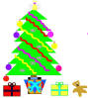
In northern and eastern parts of France this is celebrated on the 6th of December just as in Germany. Saint Nicolas, the patron saint of children, brings sweets and small gifts and in some towns there is even a procession, where a St. Nicolas figure throws out sweets to the children.

Christmas trees (des sapins de Noël) appeared in Alsace in the 14th century and were introduced to the rest of France in 1837.
Santons
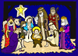
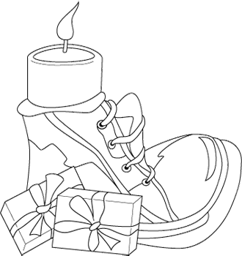
A crèche is also a popular centre-piece in French churches and homes except that in France especially in the South, there are more figures in the scene. They add figures (Santons) representing people from their village, the mayor, tradesmen etc, all coming to worship the baby. These figures are often handcrafted and often become family heirlooms. Living crèches in the form of plays and puppet shows based on the Nativity are commonly performed to teach the important ideas of Christianity and the Christmas celebration.

Les cadeaux
Instead of hanging up stockings on Christmas Eve, French children leave their shoes (des chaussures) by the fireplace. In most areas the children receive their presents from Père Noël and his companion, Père Fouettard who keeps track of the bad children and reminds Père Noël not to give them gifts. In some areas le petit Jésus brings the presents instead of Père Noël. Some adults have their presents at New Year instead of at Christmastime.
La Veille de Noël
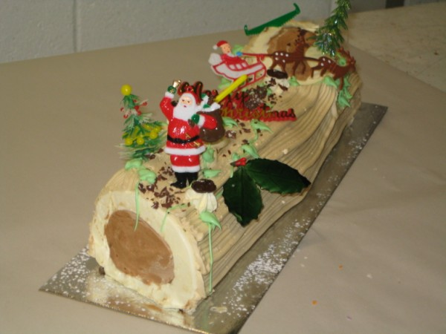
Although not all French people attend Midnight Mass (la Messe de Minuit) on Christmas Eve anymore, it is still an important part of Christmas for many families. It is followed by a huge celebratory meal, called le Réveillon (from the verb réveiller, to wake up or revive). Le Réveillon is a symbolic awakening to the meaning of Christ's birth and is the culinary high point of the season, which may be enjoyed at home or in a restaurant. Each region in France has its own traditional Christmas menu, with dishes like oysters, foie gras, turkey, capon, goose and boudin blanc.

Christmas pudding and mince pies are British and French people don’t normally eat them. Instead they have a special cake called une bûche de Noël, which is a log-shaped cake made of chocolate and chestnuts. It is representative of the special wood log burned from Christmas Eve to New Year's Day in the Périgord region of France. In some parts of France it is traditional to eat 13 puddings (to represent Jesus and his 12 disciples.)
Le Jour de l’An

Celebrations take place on le 31 décembre or La Saint-Sylvestre to welcome in the New Year. New Year is called Le Jour de l’An and you wish someone Bonne Année. It is much more usual to send cards at this time of year in France rather than at Christmas time. The only thing to remember is that they are supposed to arrive before the end of January.

La fête des Rois (le 6 janvier) or Epiphany is also marked in France
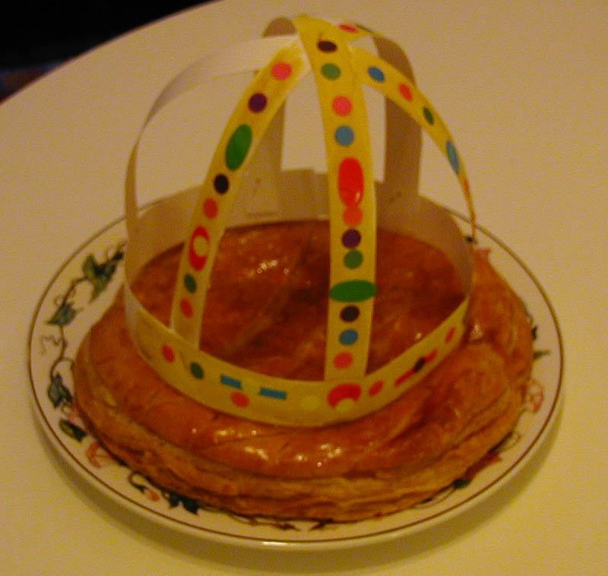
and marks the end of the Christmas celebrations. It is the festival to remember the Three Wise Men and a special cake is eaten on this day. This is called la galette des rois as the person who finds the lucky charm (la fêve) in their piece becomes the king or queen for the day and wears the crown that has decorated the cake.
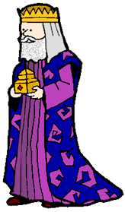
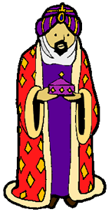
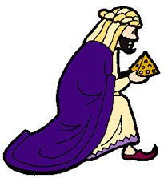


Weihnachten

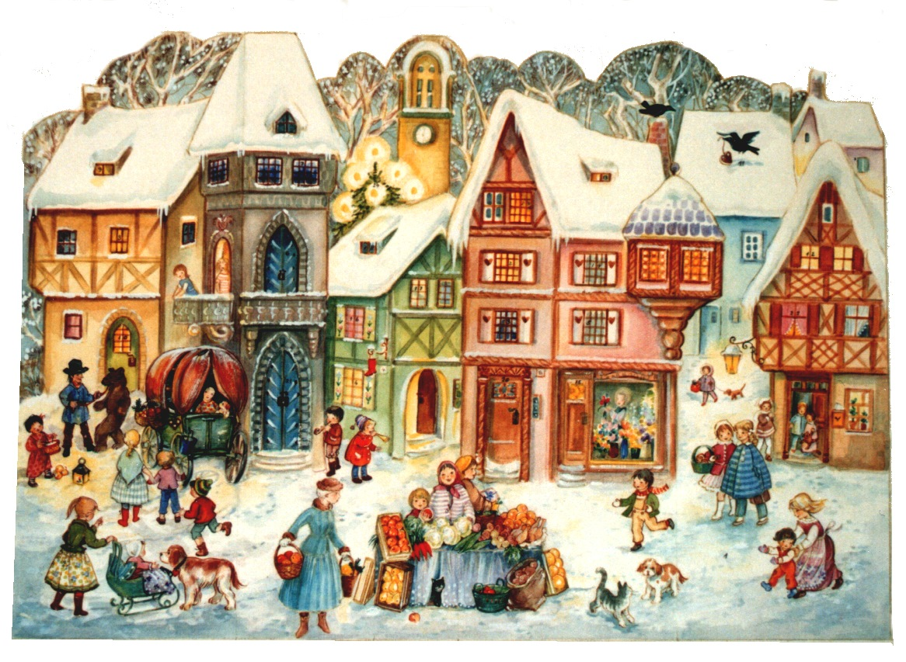
Christmas is called Weihnachten in German and a Happy Christmas is Frohe Weihnachten or Fröhliche Weihnachten. Christmas Eve is der Heiligabend, Christmas Day is der erste Weihnachtstag. Christmas in Germany is usually a very traditional festival and the festivities get under way well before Christmas Day. Celebrating the Advent period, plays a special part in preparing for the big day.
Advent calendars are a German invention that became a custom at the turn of the 20th century and has since advanced to worldwide popularity.
A Christmas Market (der Weihnachtsmarkt) takes place in many towns in German speaking countries throughout the winter holiday season. Stalls sell Christmas decorations, often hand-crafted, candles (Kerzen) and gifts and lots of traditional, seasonal food and drink such as Lebkuchen, Stollen, Marzipan and Glühwein. There is often music playing and a visit to the Christmas market is very atmospheric. One of the most famous Christmas Markets is the Christkindlmarkt in Nürnberg. In recent years some German type Christmas Markets have sprung up in England, too. Edinburgh and Lincoln are good examples.
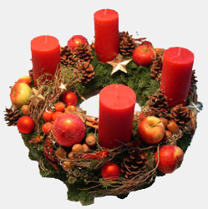
Advent wreath

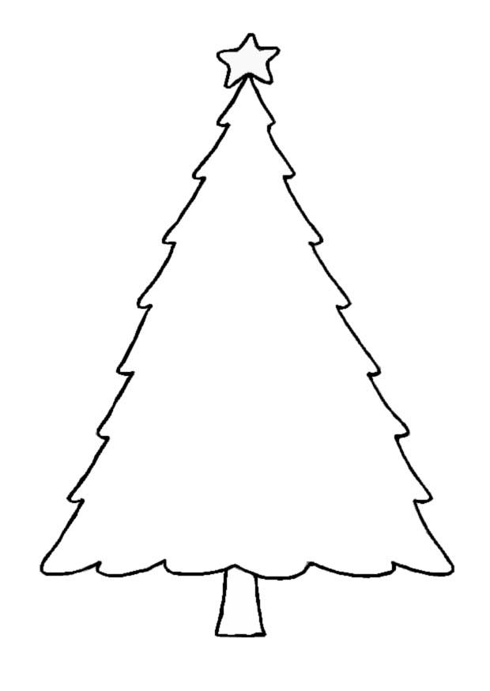
An Advent wreath (der Adventskranz) often made of evergreen branches and usually decorated with four candles—is one of the most popular symbols of the season. Originally decorated with 24 candles, one for each day of Advent, the number has long been reduced to four, symbolizing the four Sundays before Christmas. With each new Sunday, another candle gets lit so that by the last Sunday before Christmas, all four candles are burning. On these days families often gather to light the candles and to sing carols and read Christmas stories together. They would also enjoy eating some of the many types of special Christmas biscuits that are baked in Advent such as the spicy Lebkuchen.

The Christmas tree or der Weihnachtsbaum is usually only decorated on Christmas Eve and often the children are not allowed in the room until it is finished and a bell is rung. Traditionally real candles were used to decorate the tree. Prince Albert, Queen Victoria’s German husband, made the tradition of having a Christmas tree in the house widely popular in Britain.
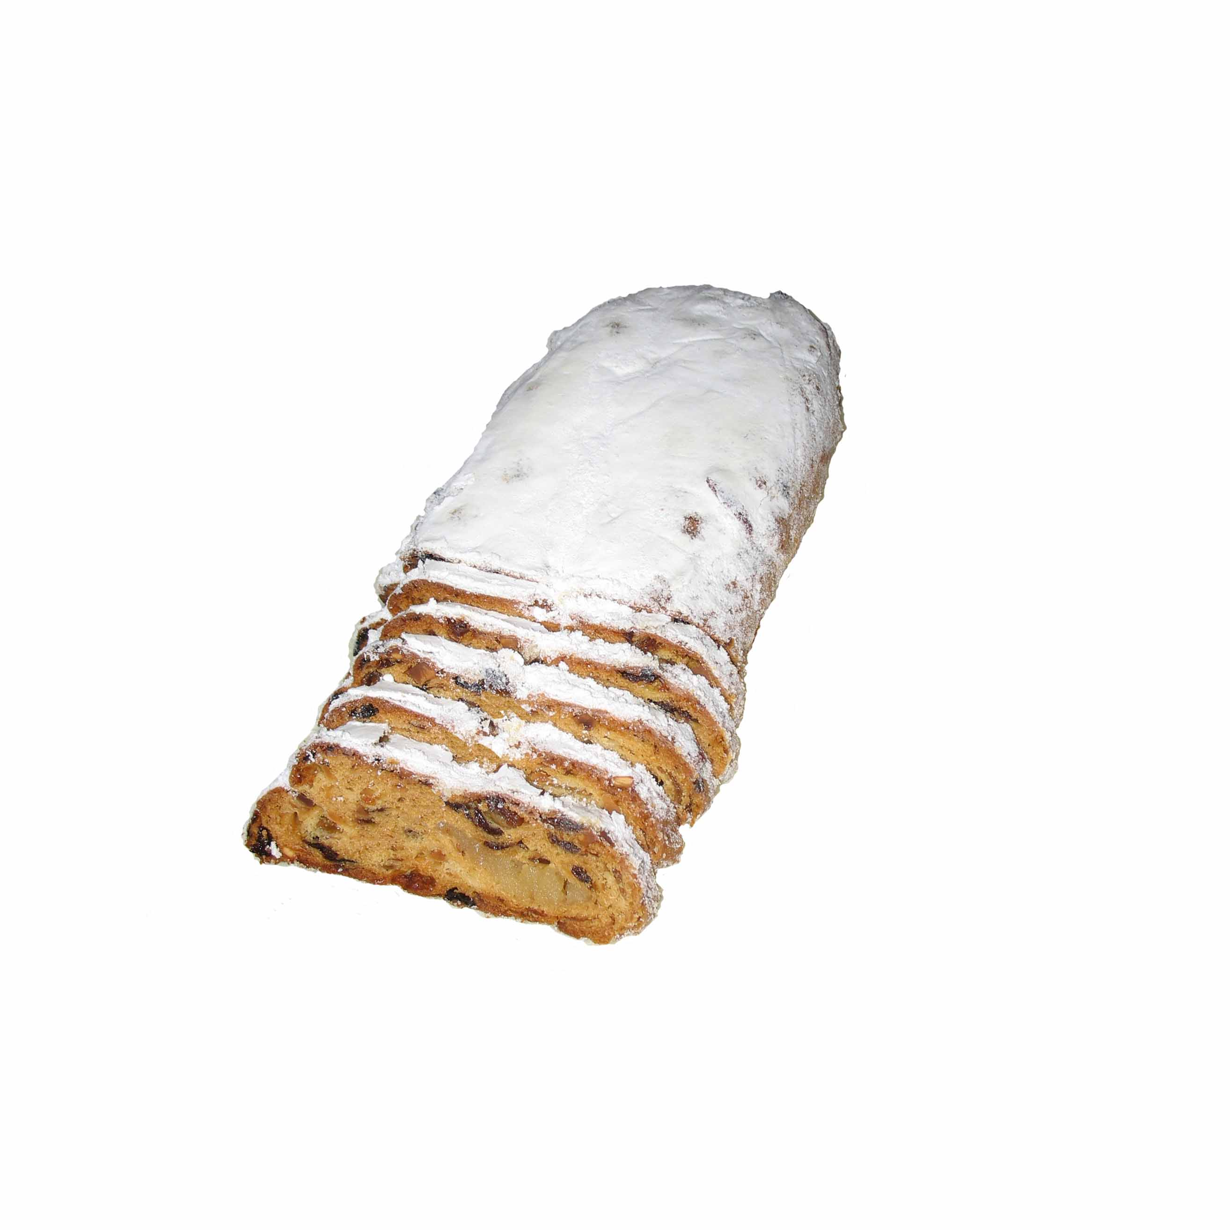
Large celebratory meals are enjoyed late on Christmas Eve and also on Christmas Day. Traditionally many people eat roast goose or pork or fish such as carp. Germans have a special cake called Stollen, which originated in Dresden. This is a bread-like cake with dried fruits and peel, possibly soaked in rum and sometimes with a roll of marzipan through the middle. It isn’t iced like British Christmas cakes, but is dusted with icing sugar.

Silvester
New Year is called Silvester and you wish someone ein gutes neues Jahr. This festival is more for adults with parties and firework displays, but children may be interested in the good-luck symbols such as ladybirds, horseshoes, four-leaved clover leaves, toadstools, chimney sweeps and even pink piglets made of marzipan that some people give each other for the New Year. Dreikönig or Epiphany is a holiday in Germany and marks the end of the celebrations, when the tree is taken down. The Three Wise Men are remembered and sometimes children dress up as kings (Sternsinger) and go carol singing to collect money for charity.
Sankt Nikolaus
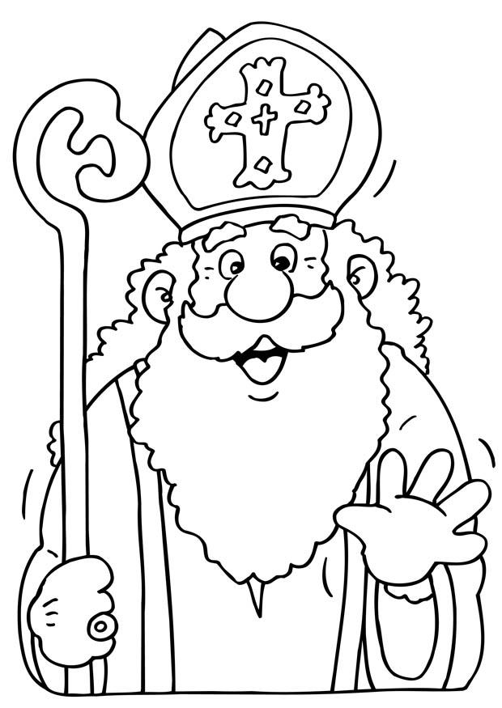
On the 6th of December (der Nikolaustag), Sankt Nikolaus visits the children. On the night of the 5th of December, the children leave their cleaned shoes outside the door. The next morning, the shoes will have been filled with sweets, nuts, fruit and small gifts. He may have even left a Nikolausteller.
Sankt Nikolaus looks very much like Father Christmas apart from his hat. Nikolaus wears a mitre-like hat and carries a bishop’s staff.
Assisting Sankt Nikolaus is his servant Knecht Ruprecht. He is normally dressed in a brown robe and carries a black book with the names of children who have been naughty and bundles of twigs to give them instead of sweets.
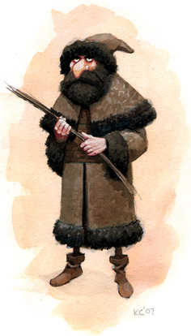
Presents (Geschenke) are usually opened on Christmas Eve. This is called die Bescherung. In the South they are brought by das Christkind, an angel in white robes and crown, sent as a messenger from the Christ Child. In the North they are brought by der Weihnachtsmann, who looks like Father Christmas.
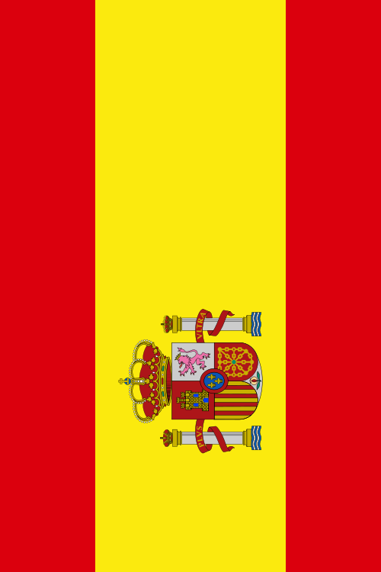
Feliz Navidad

The Christmas season in Spain starts on the 8th December in Spain, when the feast of the Immaculate Conception is celebrated.
The more common traditions include incredibly elaborate "Nacimiento" (nativity scenes), Christmas trees, and remarkable Christmas markets scattered among villages and cities with piles of fruits, flowers, marzipan and other sweets, candles, decorations and hand-made Christmas gifts. Often, as the Christmas Eve stars appear in the heavens, tiny oil lamps are lighted, warming village windows.
The Christmas Eve gaiety is interrupted at midnight by the ringing of bells calling the families to "La Misa Del Gallo" (The Mass of the Rooster). The most beautiful of these candlelight services is held at the monastery of Montserrat, high in the mountains near Barcelona, which is highlighted by a boy's choir described as performing the Mass in "one pure voice."
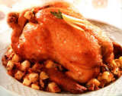
Christmas dinner is never eaten until after midnight. It is a family feast, and often highlighted with "Pavo Trufado de Navidad" (Christmas turkey with truffles; truffles are a mushroom-like delicacy found underground). After the meal, family members gather around the Christmas tree and sing Christmas carols. An old Spanish verse says..."Esta noche es Noche-Buena, Y no es noche de dormir" (This is the goodnight, therefore it is not meant for sleep.)
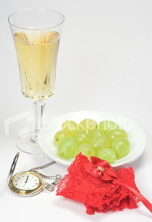
A custom peculiar to Spain is that of "swinging." Swings are set up throughout the courtyards and young people swing to the accompaniment of songs and laughter. Swinging at the winter solstice time may date back to an ancient desire to encourage the sun to "swing" higher in the sky.

The Spanish tradition on New Year’s Eve, at midnight, is to eat 12 grapes; one for each chime of the bells which ring in the New Year. This is supposed to bring good luck for the coming year.

El día de Reyes

It is not Santa who comes to Spain bearing gifts, but the Three Wise Men. On the Eve of Epiphany, January 5th, children place their shoes on the doorstep, and in the secret of the night, the Three Wise Men pass leaving gifts. January 6th, Epiphany is heralded with parades in various cities “La Cabalgata de los Reyes” where candy and cakes are distributed to throngs of children.
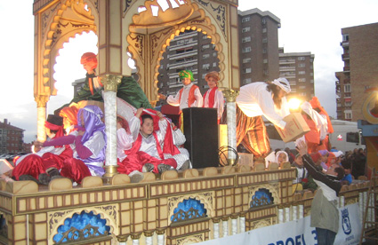


Natale
Christmas is called Natale in Italian and to wish someone a Happy Christmas you say Buon Natale. The Christmas season lasts for three weeks, from December 8th to Christmas Eve, and can include a novena, or nine-day period of religious devotion. During the novena, children sometimes go from house to house to recite Christmas poems in return for small coins with which they buy sweets. In another Italian tradition, children write letters to their parents, extending wishes for a wonderful Christmas celebration and including promises that they will be good.
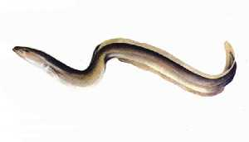
December 24th is a day of abstinence from meat, with a large celebratory meal (Cennone) in the evening. . In some places, Christmas Eve dinner consists largely of fish. There may be as many as 10 to 20 fish dishes prepared. In Rome, the traditional dish of Christmas Eve is Capitone, a big female eel, roasted, baked or fried. North of Rome a traditional dish may be pork sausage packed in a pig's leg, smothered in lentils, or turkey stuffed with chestnuts. A traditional vegetable dish is cardoni, of which Jerusalem artichokes and eggs are the chief ingredients.

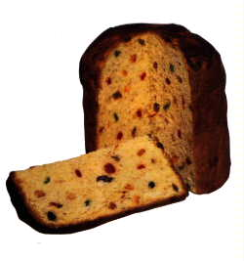
Common throughout Italy are the Christmas sweets: panettone (cake filled with candied fruit), torrone (nougat), cannoli (pastries filled with cream cheese) and panforte (gingerbread) made with hazelnuts, honey and almonds. All Christmas sweets, as a rule, contain nuts and almonds. Peasant folklore theorizes that to eat nuts favours the fertility of the earth and aids in the increase of flocks and family. In ancient Rome, honey was offered at this time of year so that the new year might be sweet.

Another tradition is the burning of the Yule log, which must stay alight until New Year's Day. This is an example of pagan and Christian traditions blending together. The pagan belief explains the purifying and revitalizing power of fire, and that with the burning log, the old year and its evils are destroyed. Christian legend tells how the Virgin Mary enters the homes of the humble at midnight while the people are away at Midnight Mass and warms her newborn child before the blazing log.
Il Presepio
Traditionally, the main focus of Christmas decorations in Italy is the presepio or crib. Nearly every church will have a presepio and they are often found outdoors in a piazza. The presepio is usually set up around December 8, the Feast Day of the Immaculate Conception. There is often a contest between churches for the best crib. People go from church to church to view and compare the cribs and displays.
Many people set up a small Christmas crib in their house too and figurines for nativity scenes are made in many parts of Italy, with some of the best coming from Naples and Sicily. An ox and ass are included amongst the figurines because legend has it that they warmed the child with their breath. The baby Jesus is only added to the nativity on Christmas Eve.
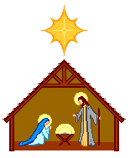
The Nativity scene or Christmas crib is said to have originated with St. Francis of Assisi in 1223. He started the tradition when he constructed a nativity scene out of straw in a cave in the town of Greccio and held Christmas Eve mass there. Greccio reenacts this event each year. Carving figurines for nativity scenes started in the 13th century.

La Befana
Although Babbo Natale (Father Christmas) and giving presents on Christmas are becoming more common, the main day for gift giving is Epiphany, when the three Wise Men gave Baby Jesus their gifts. In Italy, presents are brought by La Befana, a white-haired witch, who fills the stockings with toys and sweets for the good children and lumps of coal for the bad ones.
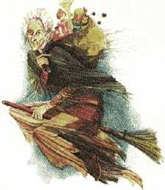
According to legend, the night before the Wise Men arrived at the manger they stopped at the shack of an old woman to ask directions. They invited her to come along but she replied that she was too busy sweeping her house. Then a shepherd asked her to join him but again she refused. Later that night, she saw a great light in the sky and decided to join the Wise Men and the shepherd after all and she took with her gifts that had belonged to her child who had died. She got lost and never found the manger. Now La Befana flies around on her broomstick each year on the 11th night, or 5th January bringing gifts to children in the hope that she might find the Baby Jesus.

